**Manual: TutorUTD**

# Table of Contents

**How to Run the Web Application Locally 2**

**Student & Tutor Features 4**

Registration Module 4

Login Module 6

Logout Module 7

**Tutor Features 9**

View Profile Module 9

Edit Profile Module 9

View Appointment(s) Module 11

Edit Appointment(s) Module 12

**Student Features 12**

View Appointment(s) Module 12

Edit Appointment(s) Module 13

Tutor Search Module 14

Select Favorite Tutors Module 15

Book Appointment Module 16

## 

# 

# How to Run the Web Application Locally

**Github link:** <https://github.com/AdithyaViswanathan1/TutorUTD>

**Note:** Due to differing permissions, the following commands could require administrator privileges and thus sudo as a prefix. Example: sudo npm i. It is recommended whoever is running this program, that they have administrator privileges on their local machine.

1. **Frontend Setup**

Recommended: Visual Studio Code with the TutorUTD/front/app folder open

All Front-end installations should be done in inside the /TutorUTD/front/app directory

Have project repo cloned to your computer (git needs to be installed)

Install NodeJS https://nodejs.org/en/download and verify installation with “node --v” and “npm --v”. Alternative: “node -v” and “npm -v”

Run “npm install -g @angular/cli” to install angular command line interface

may need “ng update typescript@4.9.3” if you get an error about cannot read property createAsExpression

Run “npm i” to install/update the project's npm packages

1. **Backend Setup**

Recommended: Visual Studio Code with the TutorUTD/back folder open

Required: Local installation of Python (Developed with 3.1)

All Back-end installations should be done in inside the /TutorUTD/back directory

Ensure the following libraries are installed using pip:

* django
* pymysql
* djangorestframework
* django-storages
* boto3
* django-cors-headers
* duo_client
* django_crontab

Additionally, the file secrets.json (given as part of submission files) has to be placed in TutorUTD/back directory for the final website to work. It is not included in the git repository for security reasons. This file should remain confidential.

1. **Run Application**

BACKEND

Run command “python manage.py runserver” in TutorUTD/back directory. Alternative: “python3 manage.py runserver”

FRONTEND

Run command “ng serve” in TutorUTD/front/app directory. Alternatively, go to the run and debug tab on the visual studio code sidebar then click run locally at the top of the panel. Once the task runs it should pop up a browser window with the application, if not check the vsCode console for a link to the localhost page.

Final website will be at the URL address given by the “ng serve” command.

IMPORTANT: In order for the app to work, both frontend and backend commands have to be running in their respective directories.

# Student & Tutor Features

## Registration Module

1. Click on Student Sign-up or Tutor Sign-up from the homepage

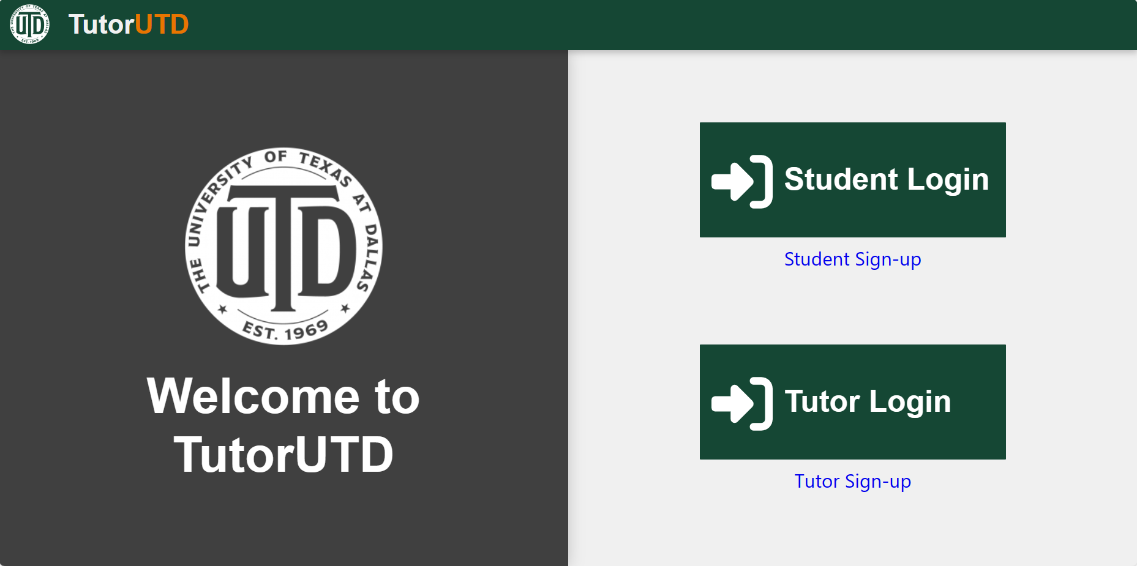

1. Fill out the information and click “Sign Up”. Password requirements include:
   1. Password should contain at least 8 characters
   2. Password should contain at least 1 uppercase letter
   3. Password should contain at least 1 special character

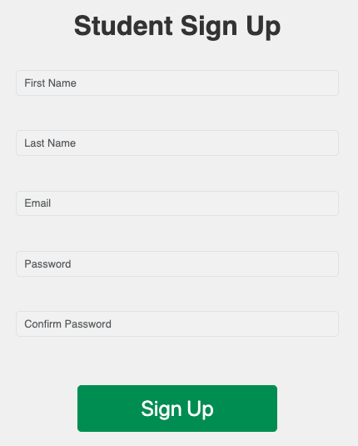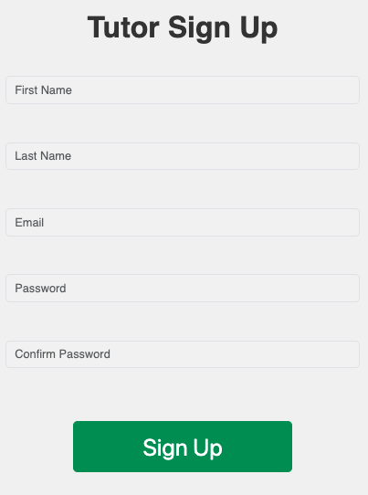

Upon registration, a confirmation email will be sent

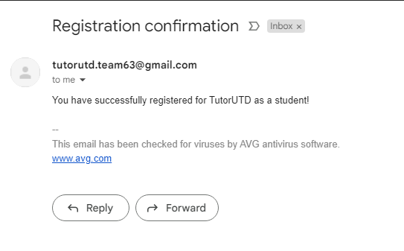

1. Download Duo Mobile app on smartphone (available for iOS and Android).

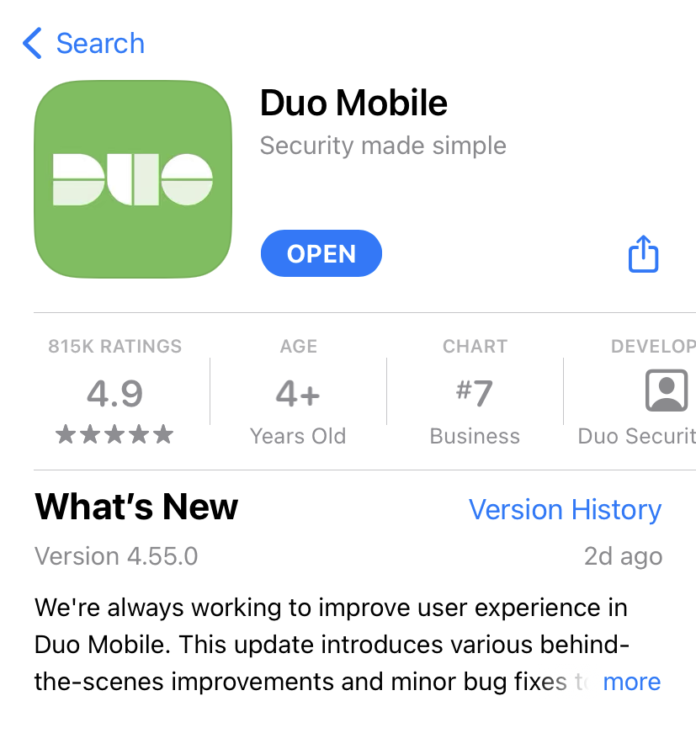

1. Open the Duo app and click on “Add +” button on top-right corner. Then, click on “Use QR code” button.

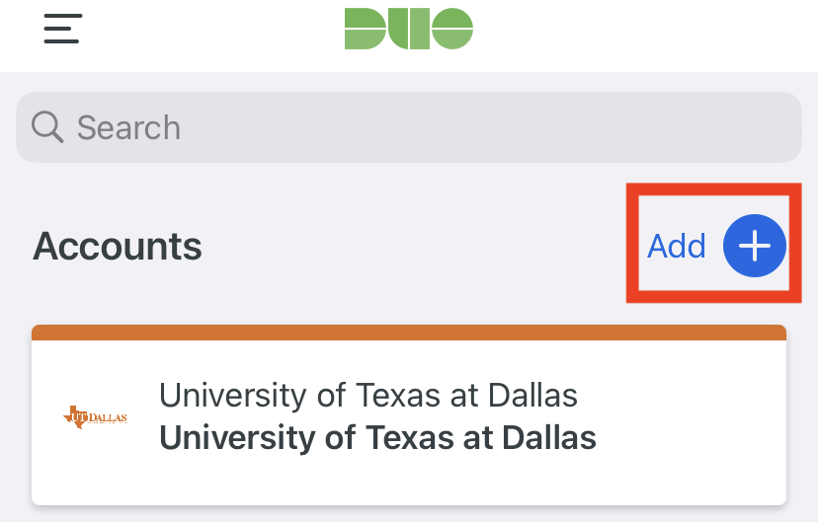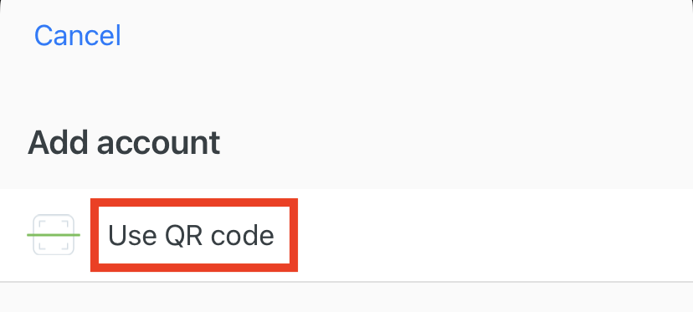

1. Scan the QR code displayed on the website using your mobile phone. Your account as well as 2 Factor Authentication have now been activated. You will need to allow access to your account using Duo every time you want to login.

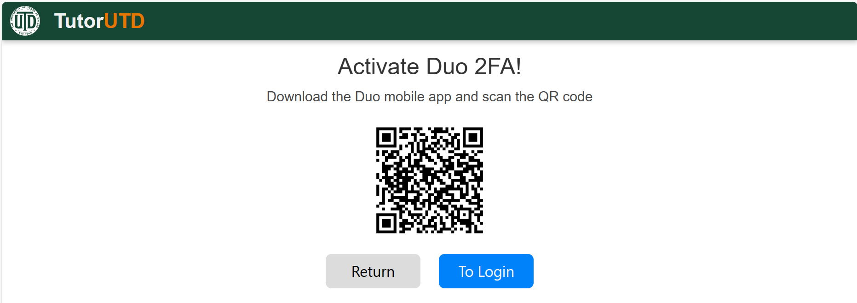

## Login Module

1. Click on Student or Tutor Login from the homepage or “To Login” from the Activate Duo 2FA page
2. Fill out the information and click “Log In”

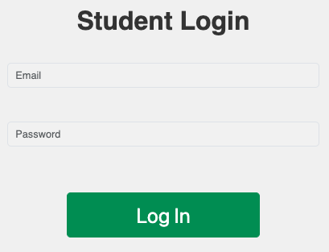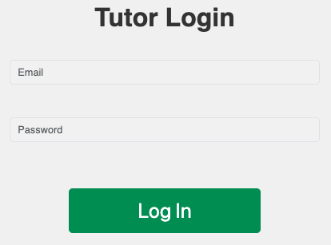

1. Authentication
   1. If users scanned the QR code when registering: from your device, a ‘Push’ notification from Duo will be given. Press ‘Approve’ to continue and proceed to Step 4.

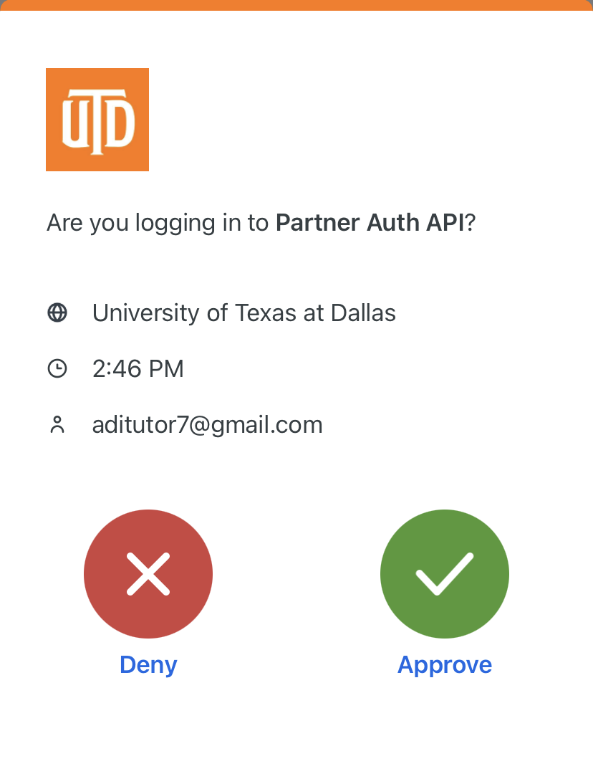

* 1. If users did not scan the QR code when registering: users will land on the Activate Duo 2FA page. Follow Steps 3-5 of the Registration module. Then, return to Step 1 of the current module.

1. After a successful login, student users will land on the appointments page and tutor users will land on their profile page.

## Logout Module

1. From the top right of the navigation bar click on the person icon.



1. A logout dropdown should appear. Click it.

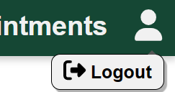

1. After successfully logging out, users should be redirected to the homepage.

# Tutor Features

## View Profile Module

1. Follow steps in Login Module
2. Profile is shown immediately. This includes name, biography (personal info, experience, meeting information, etc), profile picture, course list, and available times. We allowed tutors to have the flexibility to express their meeting method, either an in-person meeting location on-campus or an online meeting method (Zoom link, Blackboard Collaborate meeting room, etc.)

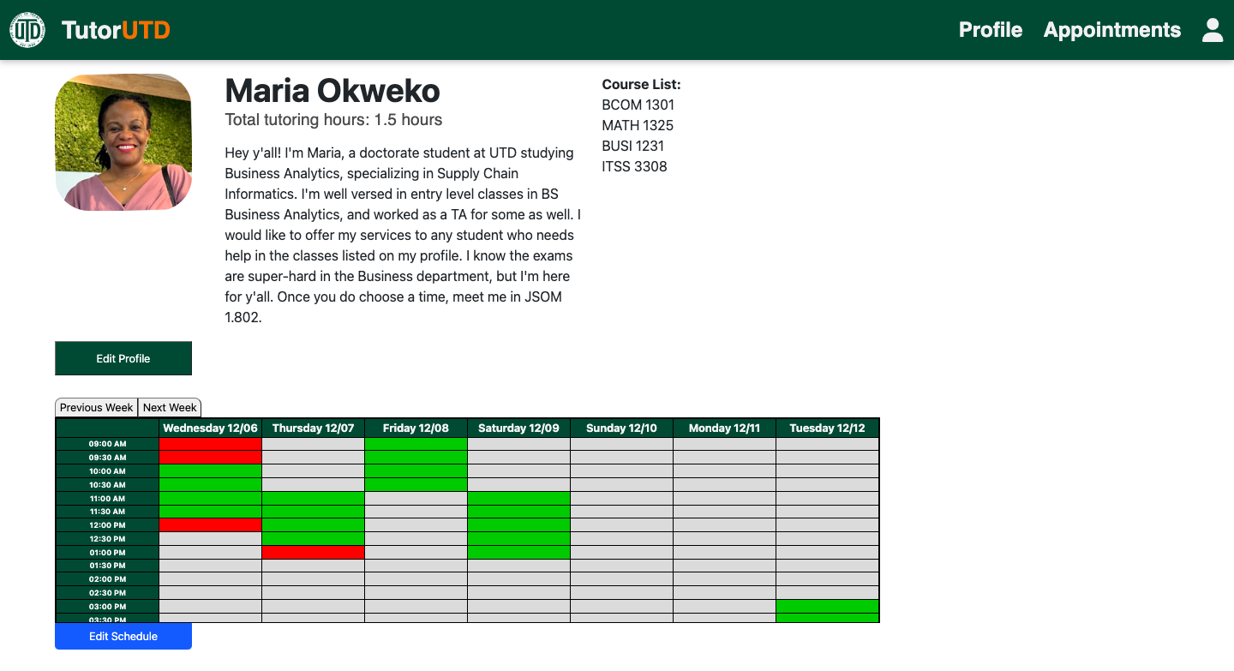

## Edit Profile Module

1. Follow steps in Login Module
2. Profile is shown. Click the “Edit Profile” button to edit fields such as biography, course list, and name (See Step 3). Click the “Edit Schedule” button to edit available times for tutoring (See Step 4). Clicking the profile picture image will bring up a file explorer to allow for custom image upload by the user.

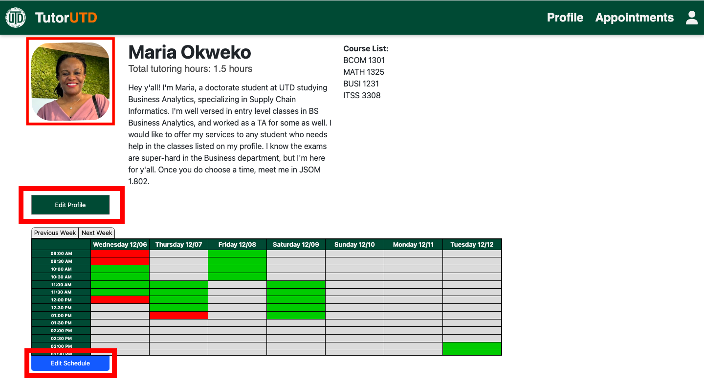

1. Edit profile fields as necessary. Confirm changes by clicking “Save” or cancel changes by clicking “Cancel”

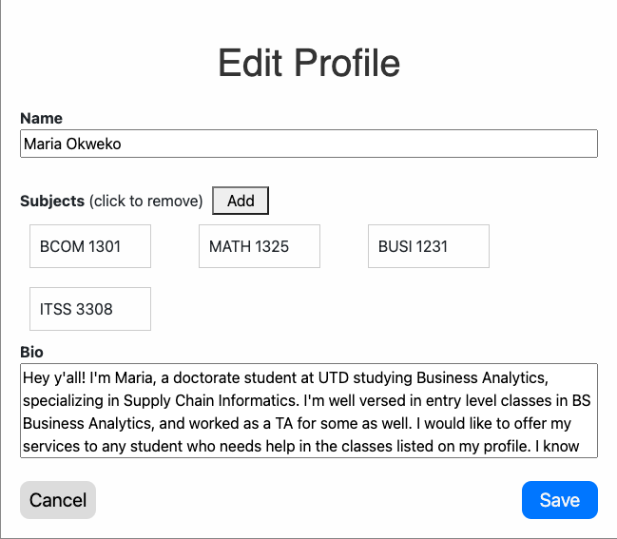

1. Edit available times by selecting white slots, turning them into green slots. Red slots cannot be modified since they are previously booked appointments. Selected times will be applied to future weeks as well.

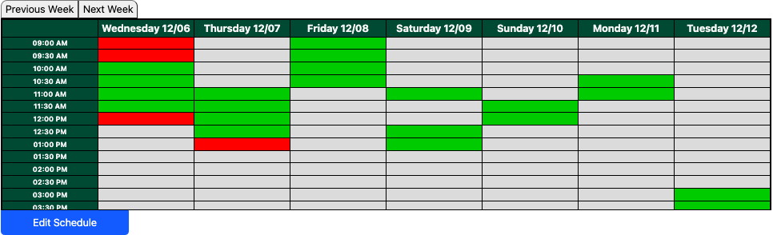

## View Appointment(s) Module

1. Follow steps in Login Module
2. Click “Appointments” on the taskbar, located at the top of the screen



1. Upcoming Appointments are displayed in a list view in addition to a calendar view.

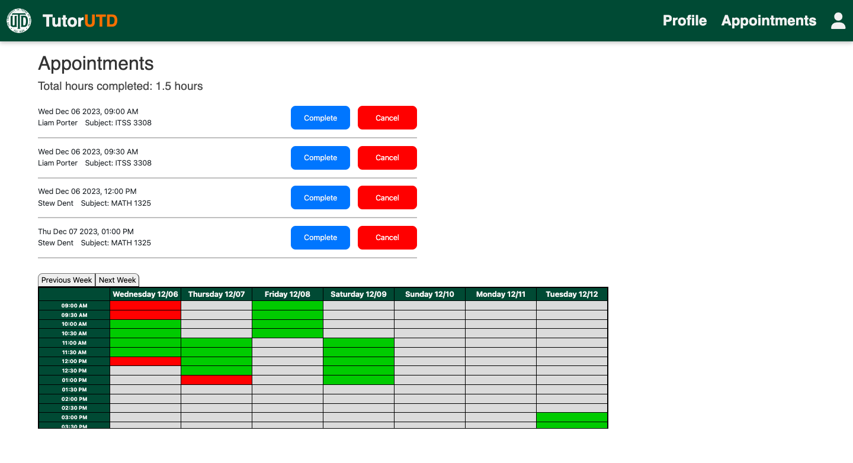

### 

## Edit Appointment(s) Module

1. Follow steps to View Appointments
2. Each appointment can be marked “Complete” or “Canceled”. Both options will remove the appointment from the list.

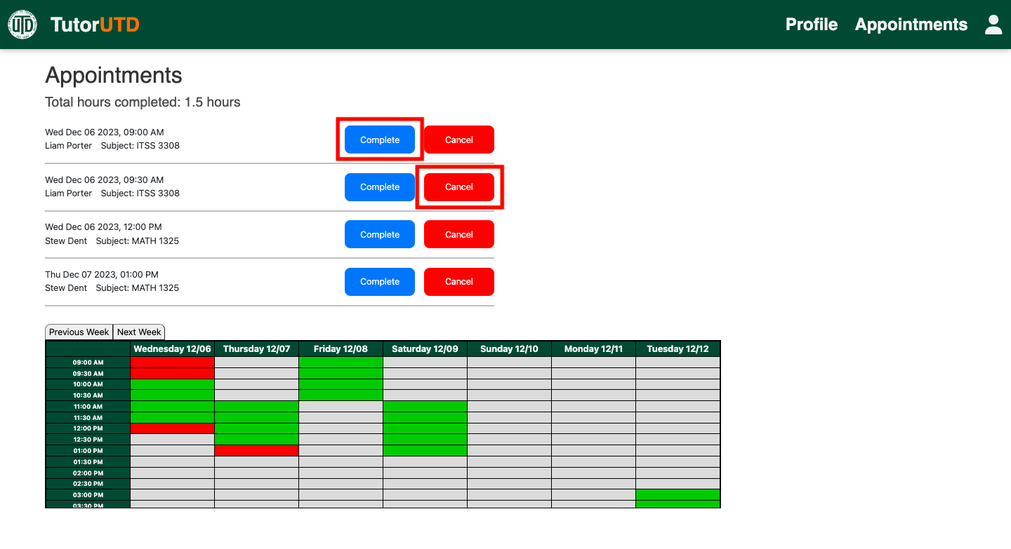

1. When an appointment is canceled, a confirmation email will be sent to both the student and tutor.

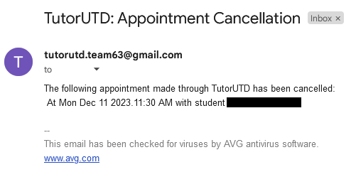

# Student Features

## View Appointment(s) Module

1. Follow steps in Login Module
2. Appointment(s) is shown immediately. Each appointment is listed with time, date, tutor name and subject. Clicking “View Profile” will go to that respective tutor’s profile.

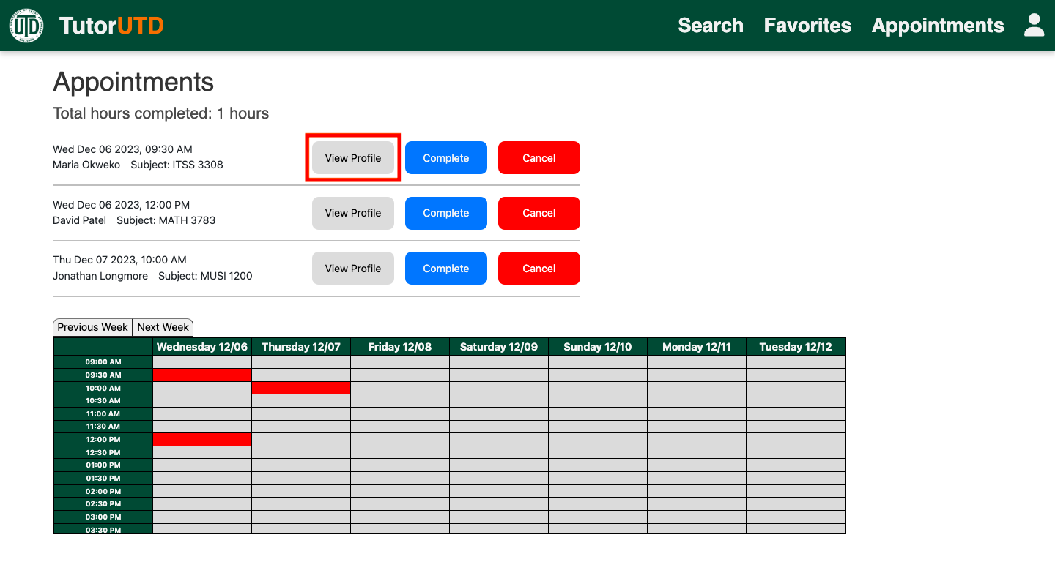

## Edit Appointment(s) Module

1. Follow steps to View Appointment(s)
2. Appointments can be marked finished by clicking “Complete” or canceled by clicking “Cancel”. Both options will remove the appointment from the list view and calendar view.

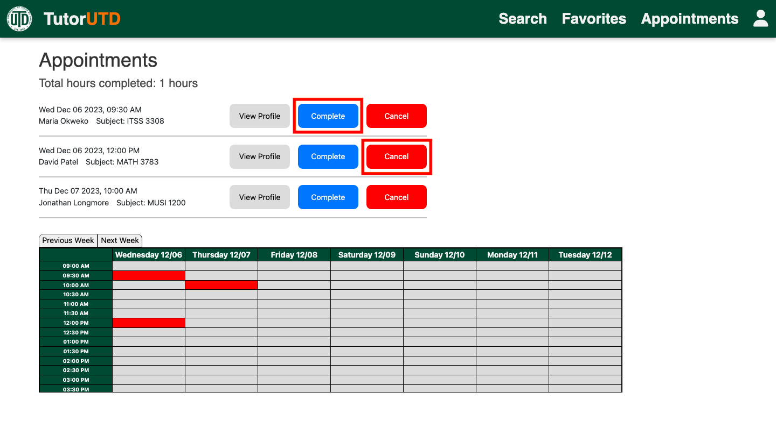

## Tutor Search Module

1. Follow steps in Login Module
2. Click “Search” on the taskbar, located at the top of the screen



1. Search can be done through the following 3 ways:
   1. Course prefix only (MATH)
   2. Course prefix and number (MATH 1036)
   3. Tutor name (Kevin).
   4. All three fields blank - will return all tutors in the system

Enter search values in their respective fields and click “Search” to view matching tutors. Matching tutors will be listed with their profile picture, name, subjects, and a link to go to their profile.

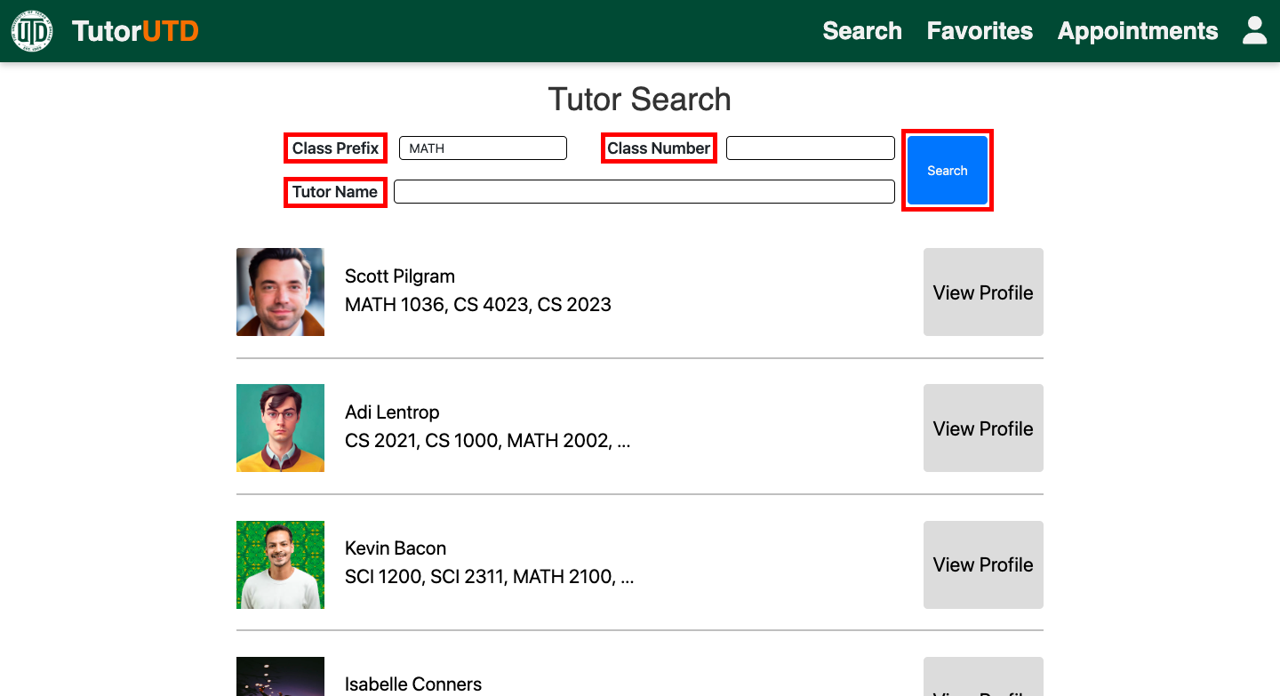

1. Clicking “View Profile” on a tutor from the search result will bring up the tutor's profile.

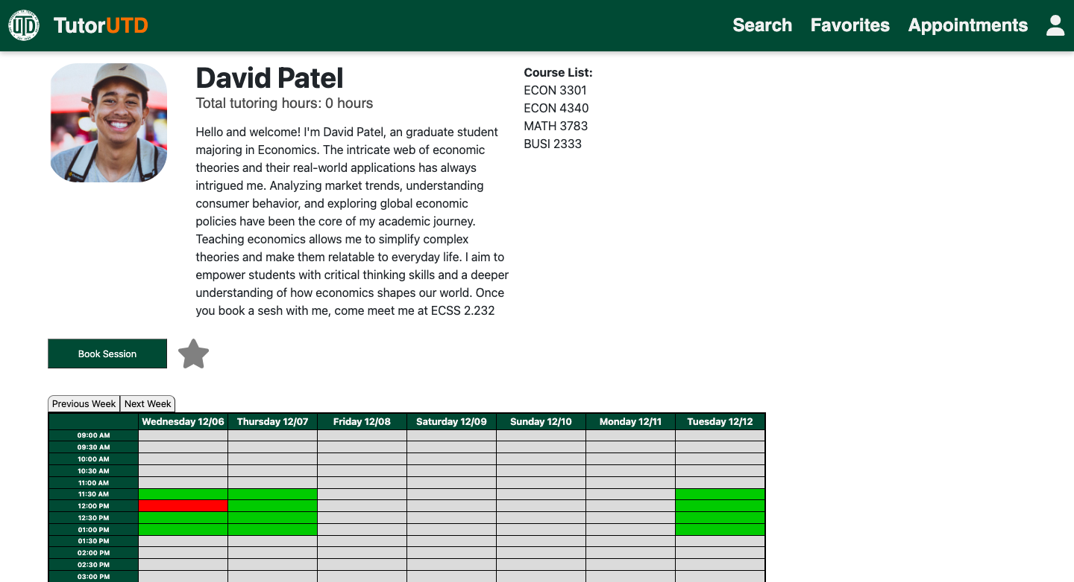

## Select Favorite Tutors Module

1. Follow steps to view a tutor’s profile, either through Search or Appointments page
2. Once the profile is shown, click the “Star” button under tutor’s biography to add to favorites. Once selected, it will turn gold, meaning it has been added to your favorites list. Selecting it again will return it to gray, meaning it is no longer in your favorites list.

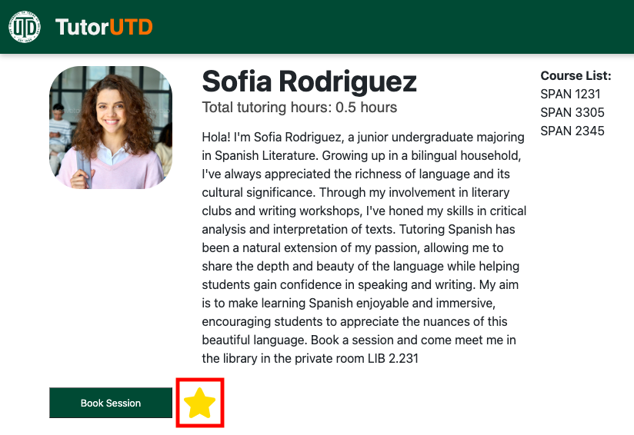

## Book Appointment Module

1. Follow steps to view the tutor's profile. This can be done using search, appointments, or favorite tutors.
2. Once in tutor’s profile, click “Book Session” button, which can be found under tutor’s profile picture

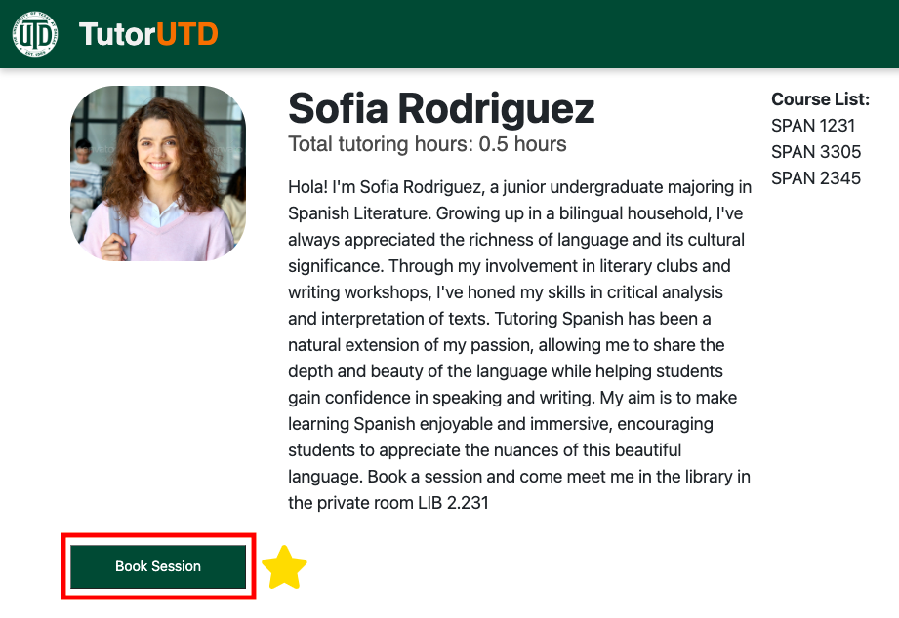

1. A pop-up will be displayed. Select a session by clicking only a green slot. Once chosen, it will turn yellow to indicate it is selected. It can be deselected by another click. Then, select a course from the dropdown of the tutor’s courses. Then click “Save” to confirm your tutoring session appointment or “Cancel” to exit without saving.

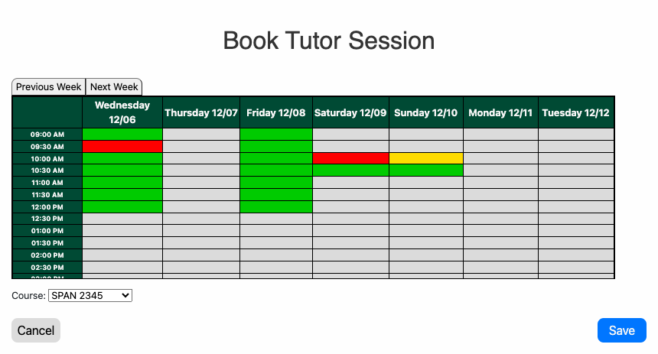

1. To confirm that the appointment is booked, it should be listed in the Appointments tab (see steps for viewing appointments if necessary). A confirmation email will also be sent to both your student email and the tutor’s email.

